**WEEK 6: 2.ReactJS-HOL (Solutions)**

Estimated time to complete this lab: **30 minutes.**

Create a react app for Student Management Portal named StudentApp and create a component named Home which will display the Message “Welcome to the Home page of Student Management Portal”. Create another component named About and display the Message “Welcome to the About page of the Student Management Portal”. Create a third component named Contact and display the Message “Welcome to the Contact page of the Student Management Portal”. Call all the three components.

**Hands-on Solutions:**

* Creating a React project named “**studentapp**” and then Creating a new folder under Src folder with the name “Components”.
* Adding ‘**Home.js**’ , ‘**About.js**’ and ‘**Contact**.**js**’ in the **Components** folder.

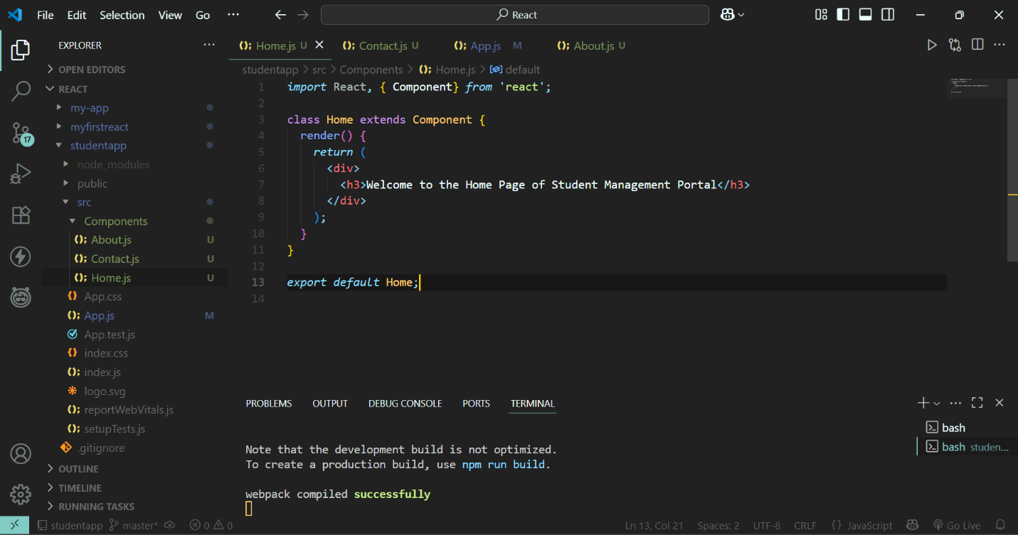

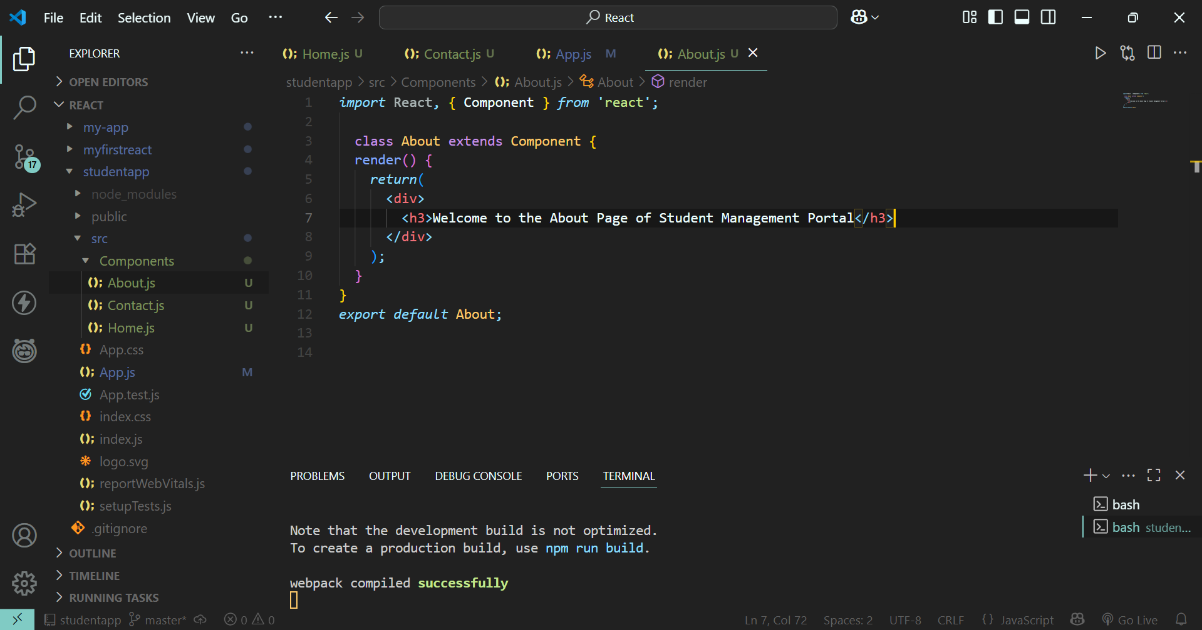

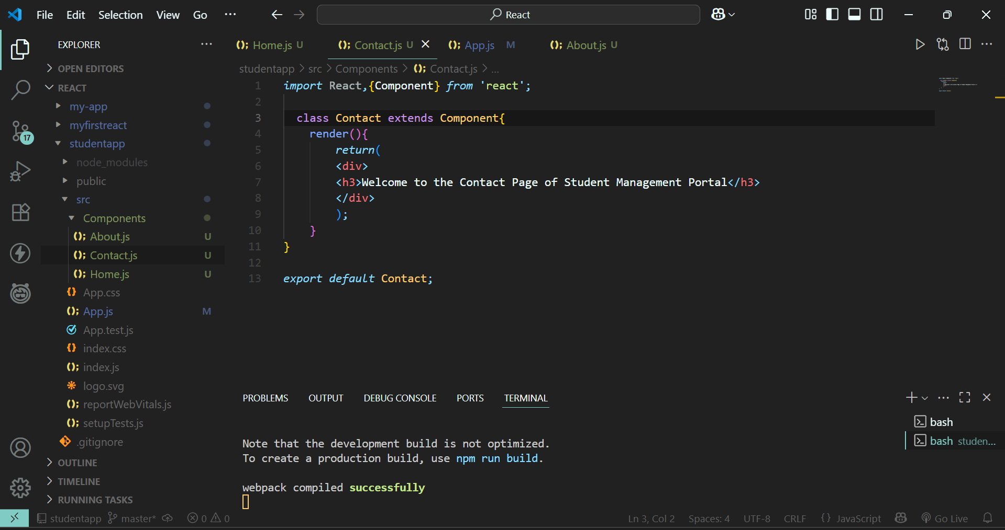

* **Invoking the Home.js , About.js , and Contact.js in App.js**

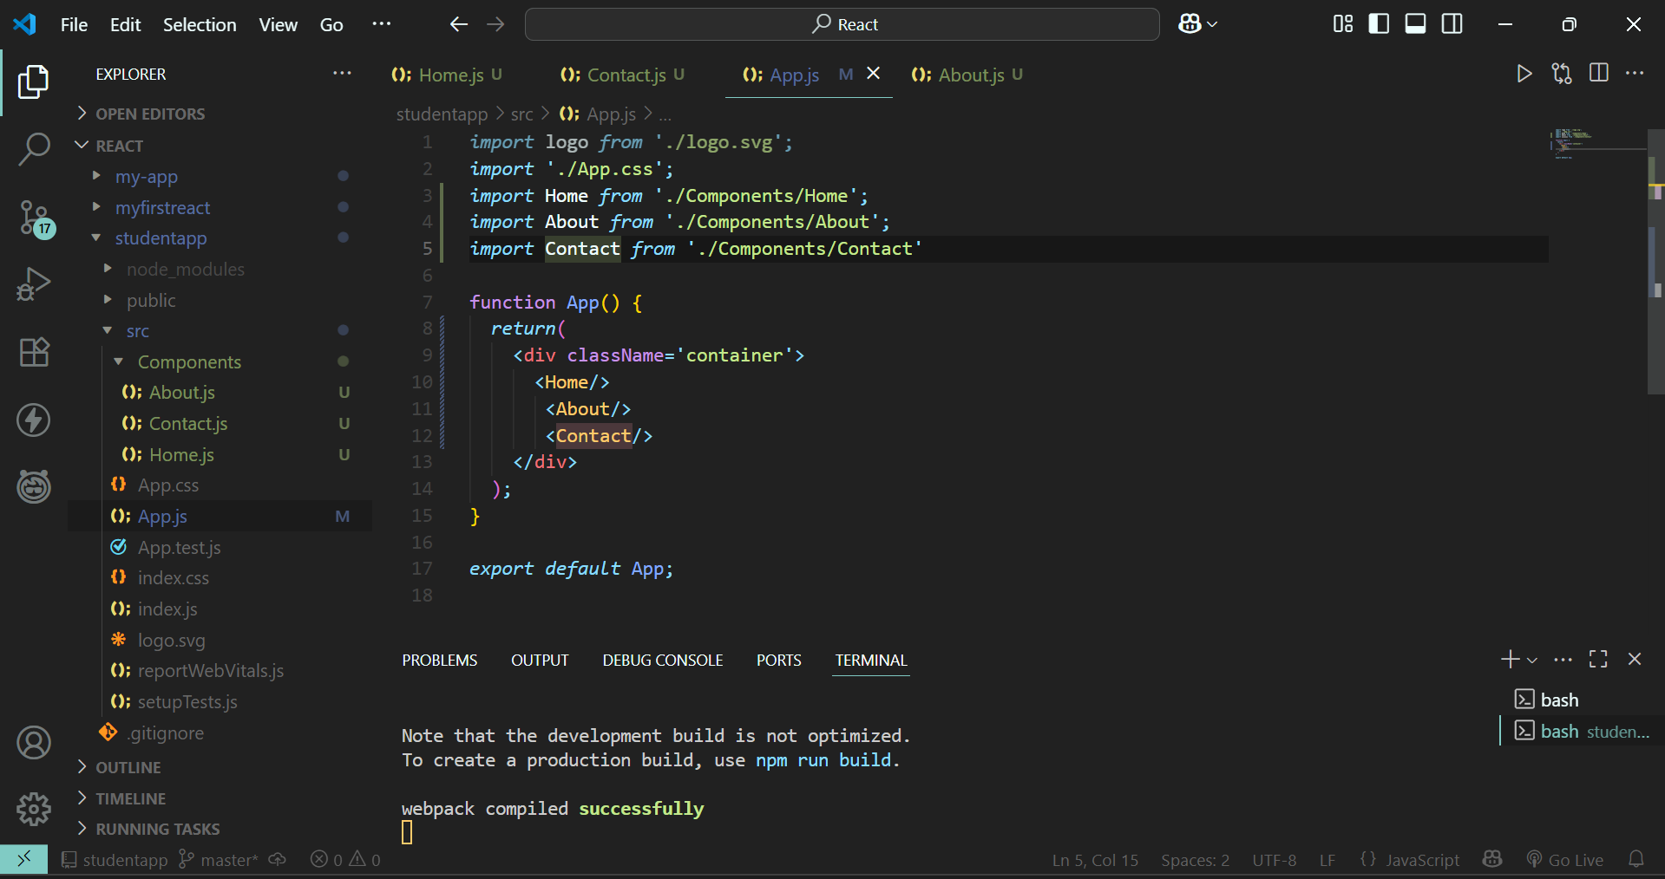

**Running the ‘studentapp’:**



